My school summer holidays!

Soon, school will close and be shut for the summer holidays. My last day is the 18th of July.
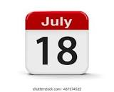

I can relax and enjoy the summer holidays. This will be good.
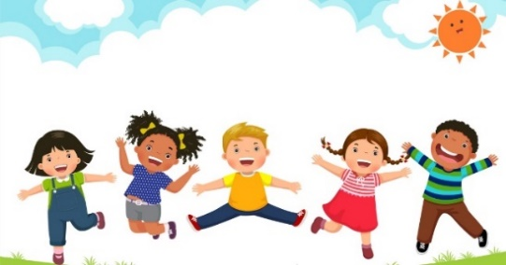

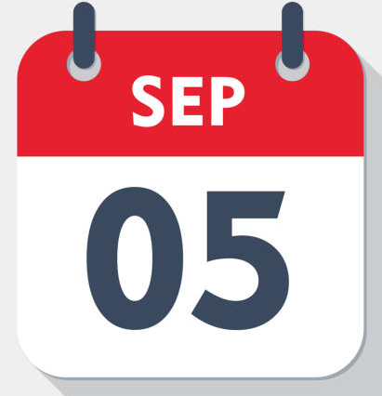
When the holidays are finished, I will go back to school on September the 5th 2023.
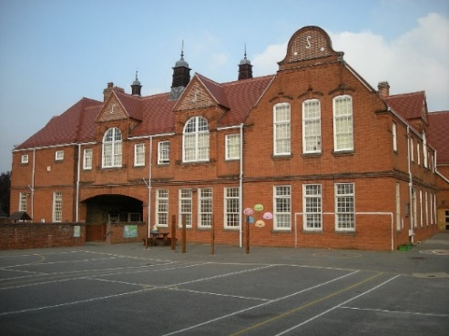
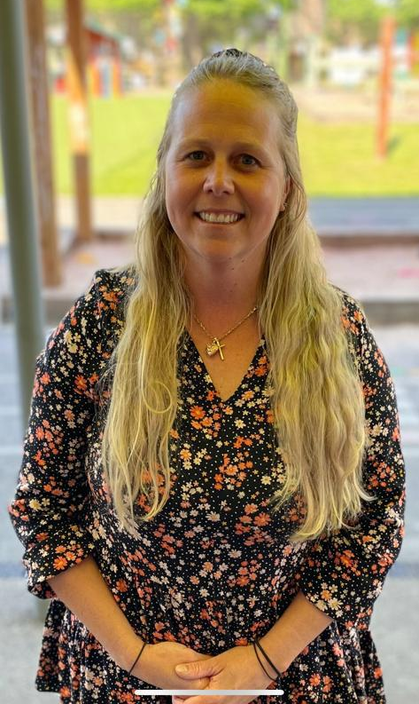

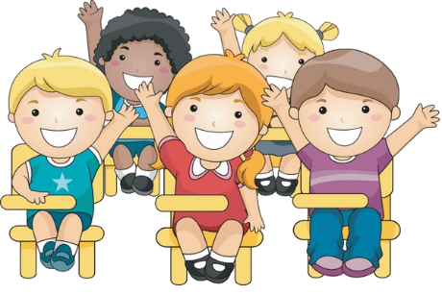
I will be in a new year group and classroom with my friends. This will feel different but exciting.
This is okay.
I will try to relax, work hard and have fun!
My new teacher for year 3 will be Mrs Palmer.
I will be in class Iceni.
I will be at Town site.

There will be some differences but a lot will stay the same:
School uniform

Friends

P.E uniform
Adults to support you.
This is good!



