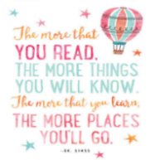
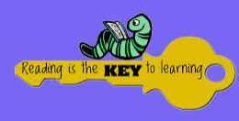
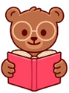  - USE A BOOK TO TELL A STORY TO YOUR TEDDY.  Completed: | - READ / LISTEN TO A BOOK IN BED.  Completed: | - READ / LISTEN TO A BOOK AND THEN WATCH THE MOVIE.  Completed: | - SHARE A BOOK OUTSIDE.    Completed:
- READ / LISTEN TO A BOOK ABOUT ANIMALS.  Completed: | READ / LISTEN TO YOUR FAVOURITE BOOK.  Completed: | 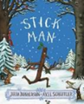  - FOLLOW ALONG TO THE STORY OF ‘STICK MAN’.  Completed: | - LOOK AT THE PICTURES IN A BOOK AND PREDICT HOW THE STORY IS GOING TO END.  Completed:
- READ A BOOK ABOUT DIVERSITY.  Completed: | - READ A BOOK ABOUT IDENTITY.  Completed: | - READ A BOOK ABOUT COMMUNITY.  Completed: | - MAKE SOMETHING FROM A BOOK.  Completed:
- SHARE A BOOK WITH A FRIEND.  Completed: | - LISTEN TO A FAIRY TALE, AND USE ACTIONS TO RE-TELL THE EVENTS.  Completed: | - LISTEN TO A FACT BOOK.  Completed: | - LISTEN TO AN E-BOOK.  Completed:
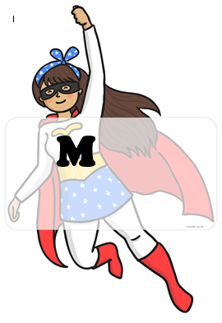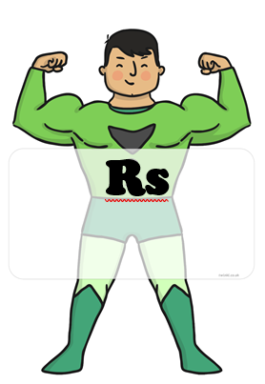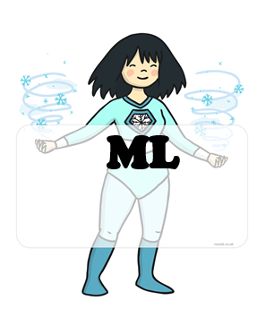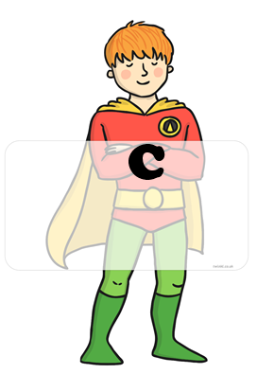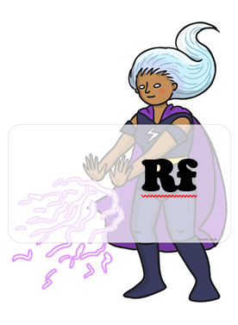 BLUE : home challenges YELLOW : school challenges

HOME CHALLENGES EVIDENCE
CHALLENGE 6:
CHALLENGE 5:
CHALLENGE 4:
CHALLENGE 3:
CHALLENGE 2:
CHALLENGE 1:
CHALLENGE 8:
CHALLENGE 7:

