
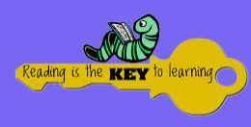
- READ A BOOK FROM THE LOCAL LIBRARY.  Completed: | - LISTEN TO AN AUDIO BOOK.    Completed: | - DESIGN A FRONT COVER FOR YOUR FAVOURITE BOOK.  Completed: |   - SHARE A JULIA DONALSON STORY  Completed:
- READ A MAGAZINE IN A DEN.  Completed: | - COUNT HOW MANY TIMES ‘THE’ IS WRITTEN IN A STORY OF YOUR CHOICE.  The or the  Completed: | - READ A FACT BOOK AND WRITE THE FACTS DOWN.    Completed: | - CREATE YOUR OWN STORY AND TELL A MEMBER OF YOUR FAMILY.  Once upon a time…  Completed:
- PREDICT WHAT A STORY IS GOING TO BE ABOUT.  Completed: |   - ANSWER QUESTIONS ABOUT A STORY SHARED IN CLASS.  Completed: | - SHARE A BOOK WITH A CHILD FROM A DIFFERENT CLASS.  Completed: | 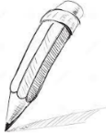  - DESIGN A CHARACTER OF YOUR OWN.  Completed:
- ORDER THE MAIN EVENTS IN A BOOK.  Completed: | - SHARE A POEM AS A CLASS AND IDENTIFY THE RHYMING WORDS.  Completed: | - ACT OUT A STORY USING PROPS.  Completed: | - CONSTRUCT A SETTING FROM A BOOK USING CONSTRUCTION MATERIALS.  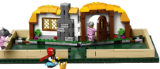  Completed:
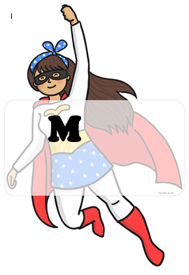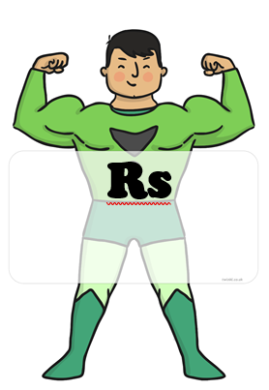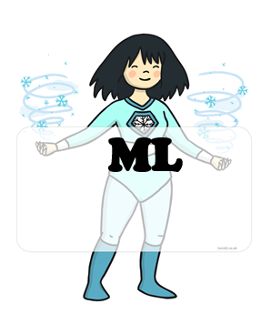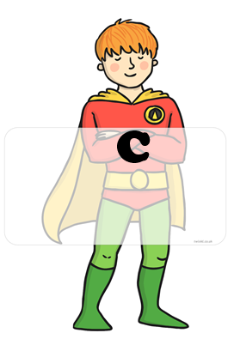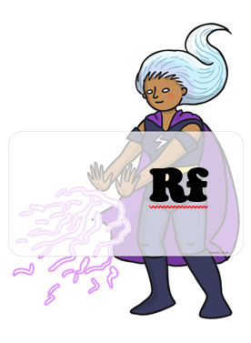 BLUE : home challenges YELLOW : school challenges

HOME CHALLENGES EVIDENCE
CHALLENGE 6:
CHALLENGE 5:
CHALLENGE 4:
CHALLENGE 3:
CHALLENGE 2:
CHALLENGE 1:
CHALLENGE 8:
CHALLENGE 7:

