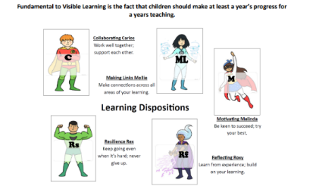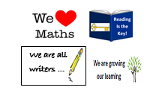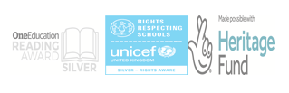
St. John’s Green Primary School
Curriculum Policy
What is our Intent?
This policy is a statement for our curriculum at St. John’s Green Primary School. Our rigorous, well planned curriculum combined with high quality teaching, ensures that children are supported to be well rounded, empathetic young people who have a genuine thirst for learning. Our children develop a strong sense of moral purpose and a respect for, and understanding of, people. It includes, not only the formal requirements of the National Curriculum, but also the range of extra-curricular activities that the school organises in order to enrich the experiences of our children. It also includes the ‘hidden curriculum’, or what the children learn from the way they are treated and expected to behave. We aim to teach children how to grow into positive, responsible people, who can work and co-operate with others, whilst developing knowledge, skills and attitudes to learning, in order to achieve their true potential.
St. John’s Green has been a Visible Learning School since 2016. We restructured our curriculum and ethos around Professor John Hattie’s principles for learning and this has been embedded throughout the school
https://visible-learning.org/

Our key values are:
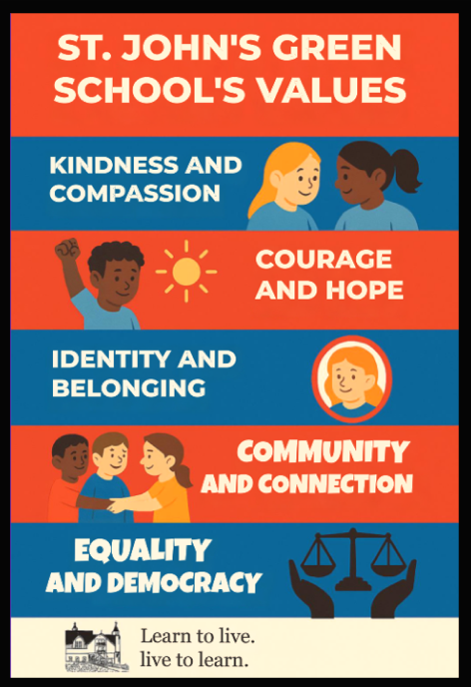

Resilience, Motivation, Reflection, Making-links and Collaboration are our Learning Powers.
We aim to ensure children learn in a progressive manner, covering the knowledge and skills of each subject to a depth that enables them to access the next stage of learning. This is supported through our Long Term and Medium Term Plans and the links we have with our local secondary schools in understanding what a Year 7 child needs to attain. We also use our local community to support our curriculum- particularly our History curriculum. We look towards the National Curriculum, to ensure we cover the statutory requirements as set out by the Department for Education and we further supplement our curriculum with enrichment experiences.
How do we implement our curriculum?
Our curriculum is implemented through a progressional and bespoke approach, with lessons being taught discretely, with cross-curricular links where appropriate. We believe it is important to celebrate each subject separately so that the children can be exposed to the subjects’ relevance and ‘awe’ elements including: significant people in the particular subject’s field, potential future jobs, and the whys to the importance of each subject. This sparks interest and allows the children to have aspirations beyond their school years. The children will be taught facts and skills which they will repeat and consolidate throughout their time at our school.
We know that “Sticky Knowledge" refers to information that children are able to recall and apply effectively over time, essentially becoming ingrained in their long-term memory. It contrasts with knowledge that is quickly forgotten. At St. John’s Green , sticky knowledge and retrieval is considered essential for long-term understanding and application of skills and therefore we timetable in Sticky Knowledge learning time, daily.
We believe that choosing the right context to engage our children in their learning is vital in fostering a love of learning and also maintaining our high standards. Our subjects (including English and Maths) are taught using the Visible Learning ethos at its core, encouraging children to make links and apply their skills with growing independence and confidence; recognising the relevance and purpose of their learning.

English
Writing
We have created a bespoke teaching approach for Writing, which embeds the ethos of the Visible Learning programme. All year groups follow a sequence of learning stages which is progressional, in our Road to Writing. We are proud that this begins in Early Years and is adapted accordingly throughout both Key Stages, into Year 6. The consistency and repetition of the teaching and learning sequences, allows children to write for purpose and develop their skills. Our Writing curriculum encourages children to make links (with writing skills, application of writing skills and other curriculum subjects), and to reflect on ‘where’ they are in their learning and ‘where’ they are aiming to be. Our children are exposed to good examples of writing and teachers and teaching staff model the writing processes as experts, using Shared Writing, continually.
Spelling
We know that spelling is an integral part of children’s reading and writing development. Learning to spell is a process of learning and then applying patterns to new words. As children develop spelling competency, their confidence and independence in writing will increase. We believe that the ability to spell enables our pupils to become writers that are more effective. We believe that children need to investigate and generate rules and patterns for themselves through planned activities. In investigating words for themselves, children begin to construct patterns and generate rules. We use Twinkl for our spelling scheme.

Handwriting
At St. John’s Green, we believe that it is important that children take pride in their work. We understand that handwriting, as with many other fundamental skills, develops at different rates for different children. It is therefore important that there is a consistent style of handwriting throughout the school so that all staff are teachers of handwriting, with a clear understanding of the progression of skills, and of how to support progress. Handwriting needs to be taught and practised with early intervention essential at every stage, to prevent the acquisition of bad habits which are difficult to correct. We use Letter Join for our scheme.
Reading and Phonics
At St. John’s Green, we are committed to teaching our pupils to become skilled readers who develop a comprehensive understanding of words, language and texts as they move through school. They learn to read and then read to learn.

Our aim is to ensure that pupils develop a love of reading so that they can read for purpose and for pleasure. We provide children with a range of reading opportunities in order to do this, including daily Shared Reading, whole class comprehension lessons and one to one sessions with adults.

At St John’s Green Primary School, we follow the Twinkl accredited phonics programme to teach our children to read. The phonics programme matches the expectations of the English National Curriculum and Early Learning Goals. We have clear expectations of pupils’ phonics progress term by term, which are fully aligned to our school’s phonics programme (Twinkl), from EYFS to Year 2. By the end of EYFS, all children should be able to read words and simple sentences accurately, with increasing speed and fluency.

Maths
In our Maths curriculum, we use White Rose Maths as the basis but we have developed our own ‘Maths Flightpath’ and this is implemented effectively, through team planning. For Maths, we use I do, We do, You do approach to model and scaffold the learning for the children.
Music
Our Music curriculum is delivered through an online package called Charanga. We value music in our school and aim to provide a high quality curriculum. Music lessons are taught using Charanga, a virtual learning tool created and run by the Essex Music Services. While singing and playing both tuned and untuned musical instruments, our children experiment with and explore the dimensions of music and are given opportunities to compose and improvise music too. The children listen to music from a range of genres, styles and traditions and learn to discuss it using their developing musical vocabulary. We learn to form an understanding of basic musical notations and develop an introductory understanding of the history of music.
Singing - We sing regularly in school as part of our learning, assemblies and productions. The children develop skills of unison, rounds, volume, pitch and tone through these opportunities. The children perform to an audience in each year group from EYFS and Year 1 singing Christmas Songs to their parents, Year 2 performing an annual musical Nativity, with Year 4 and Year 6 performing productions at Easter and the end of the Summer Term.
Our expert Music Subject Lead also teaches music lessons to every year group, which benefits both the children and supports staffs’ CPD and Music pedagogy.
ESSEX MUSIC EDUCATION HUB (EMEH) WEBSITE
Computing learning is covered using Mr P’s Scheme and EVOLVE for online Safety.. This has a number of programming elements and E-safety units.
Every child benefits from a discrete, weekly computing lesson and online safety lessons. Teachers also provide opportunities for children to access technology in other areas of the curriculum. Our computing curriculum is based on the Mr. P computing units. This scheme follows the requirements of the National Curriculum and is sequenced to allow children to build upon their computing knowledge as they progress through each year of school. The lesson plans created by the scheme have been chosen because they offer fun, creative hands-on activities which challenge misconceptions.
Our Design and Technology learning is taught using Kapow.
https://www.kapowprimary.com/blog/kapow-art-and-design-revised-scheme/
The common threads which run throughout the school and are evident in DT teaching are: Design, Make, Evaluate and the use of technical knowledge.
Science is taught using White Rose. https://whiteroseeducation.com/resources/science/primary
Through our planning, we involve problem solving opportunities that allow children to apply their knowledge, and find out answers for themselves. Children are encouraged to ask their own questions and be given opportunities to use their scientific skills and research to discover the answers. We build upon the knowledge and skill development of the previous years. As the children’s knowledge and understanding increases, and they become more proficient 3 in selecting, using scientific equipment, collating and interpreting results, they become increasingly confident in their growing ability to come to conclusions based on real evidence.

Art learning is covered through Access Art. https://www.accessart.org.uk/
Art and Design is taught on a rotation with Design and Technology every other half term. It is taught as a discrete subject but is also integrated into other subject areas when possible to create meaningful topic based learning opportunities. Lessons are delivered in a multi-sensory way with visual, verbal and practical teaching strategies employed. We recognise that prior learning is the foundation for skill progression and explicit links are made between areas of learning. This allows children to make connections between art history, techniques, and artists

Our Geography learning is taught through the Kapow scheme. Each year, geographical knowledge and skills is built upon through the teaching of the different strands from the National Curriculum. These are: Knowledge - Place Knowledge - Human and Physical Geography - Geography Skills and Fieldwork
Our History learning is though our own One Square Mile scheme of work, which we wrote as part of a National Lottery funded, two year project in 2023/2025 to mark the school’s 125 year anniversary.
https://www.onesquaremilecolchester.co.uk/
At the beginning of all units, children will look back at time periods previously studied. This encourages them to build on their chronological framework and see every unit in the wider context of time. In history, children are taught the same historical skills throughout the school but the skills are progressive and applied to time periods. We aim for our children to visit places of significant historical importance in our community.
Our PE learning is covered using Get Set 4 PE.
https://getset4education.co.uk/
P.E. is taught as an area of learning in its own right, as well as being integrated where possible with other curriculum areas. It is taught at a minimum of one PE session a week, and two sessions per week wherever possible. The key knowledge and skills of each topic are mapped across each year group. This ensures that children develop their knowledge of games, dance and gymnastics and (from KS2) athletics and outdoor and adventurous activity progressively. The skills in these areas are also therefore developed systematically, with the programme of study for each year group building on previous learning and preparing for subsequent years. Knowledge and skills are informed and linked to enable achievement of key stage end points, as informed by the 2014 National Curriculum.

Our Modern Foreign Language is Spanish. This is taught through the Language Angels Scheme.
https://www.languageangels.com/schools/
Our KS2 children have a weekly Spanish lesson of 30 minutes. Further opportunities to recycle key vocabulary (e.g. numbers) and develop children’s confidence are often built into classroom routines including greetings, providing instructions, stating lunch preferences, registration, rewards and praise on a more regular basis, even just for a few minutes in the school day e.g. when children are lining up. The Language Angels Scheme is used but teachers may, if they wish, adapt the resources to support active engagement and meet different learning styles for different cohorts of children

Sex and Relationships Education is provided throughout a child's time at St. John’s Green Primary School. We use SCARF scheme https://www.coramlifeeducation.org.uk/scarf to teach and we also interweave the more hidden curriculum through our work with our Unicef Ambassadors, School Councillors, and the work we are doing towards the Equalities Award.
Our RE curriculum follows the Saffron Academy Trust. https://www.saffron.academy/page/?title=Sat+RE+Curriculum&pid=1041
We base our teaching and learning style in RE on the key principle that good teaching in RE allows children both to learn about religious traditions and to reflect on what the religious ideas and concepts mean to them. Our teaching enables children to extend their own sense of values and promotes their spiritual growth and development. We encourage children to think about their own views and values in relation to the themes and topics studied in the RE curriculum.

Planning
The Early Learning Goals and National Curriculum objectives are incorporated into our planning. An overview of the topics covered within Years Reception-Year 6 are on our Long Term Plan and gives a broad outline and shows progression and continuity in topics and subjects taught across the school. There are three parts to our planning: Long term planning; this is an overview of the topic areas covered in each year group. Medium Term Planning: these have the specific objectives and sequences of lessons, within a subject over half a term /a term. It specifies what needs to be taught and how, with planned outcomes. For subjects except English and Maths this is the basis for teaching. Weekly Planning: These break down the objectives into weekly achievable targets and activities for English and Maths. We use our bespoke programmes of the Road to Writing and Maths Flightpath to write a follow daily plans, to ensure consistent and purposeful delivery of lesson.

Assessment
In the first Autumn term, EYFS children sit a statutory baseline test. The Reception baseline assessment (RBA) is a national assessment that will be administered in all primary, infant and first schools in England to children in reception classes.
Children in Year 1 have a statutory phonics test in June. They are required to read a set of words aloud to their class teacher. If children do not meet the threshold, they have another opportunity to do so in Year 2.
In Year 4, children sit a Multiplication Tables Check. The Multiplication Tables Check (MTC) is a statutory assessment in schools, for children in Year 4, administered in the Summer Term 2022. The purpose of the MTC is to determine whether pupils can recall their times tables (up to 12 x 12) fluently, which is essential for future success in mathematics.
In Year 6 the children sit Standard Assessment Tests (SATs) during the summer term (AP3).The results show their level of attainment in English, Mathematics and Science as set against national standards.
Focussed assessment
- Rigorous assessment and tracking of children’s performance takes place to inform classroom practice allowing children to make good progress and close attainment gaps;
- Day to day, live marking and verbal feedback used effectively;
- Assessment for Learning (AfL) evident across the school – learning objectives and success criteria
- Intervention - Individuals and groups who are not making sufficient progress are identified;
- Provision for intervention is mapped according to need and shared with our SENCo
- Bespoke plans are put into place for key children;
- Learners are enabled to perform beyond age related expectations, deepening their knowledge and understanding;
Interventions are evaluated and relevant adjustments are made; Pupil Progress Meetings take place termly to discuss current and future interventions engaging in dialogue around the impact of interventions, potential barriers and further actions required.

What is our impact?
Children leave St. John’s Green School as happy, caring and confident individuals who know how to keep safe and who do well across all subjects.
At St. John’s Green, children are assessed during every lesson which enables our teachers to plan the next steps for each child. Teachers assess against the learning objectives, Success Criteria and TAFs, and the basic skill requirements for each year group and provide live feedback which enables each pupil to make progress within the lesson and overtime. Children are expected to make good or better progress in all subjects and this individual progress is tracked and reported to parents and carers at open evening and on the end of AP reports.
Enjoyment of the curriculum promotes achievement, confidence and good behaviour. Children feel safe to try new things. The pupils will be able to work collaboratively with their peers and independently as inquisitive learners who are motivated to excel and who have a thirst for learning. The pupils will have a strong desire to embrace challenge and to be resilient learners. Our curriculum will also enable our pupils to become good citizens and demonstrate an appreciation for each other, the school community and the world. Our pupils will be respectful and will show tolerance and acceptance to those from different faiths and backgrounds.
We will measure the impact of curriculum through:
- Sonar and Pupil Progress data
- Attendance
- Behaviour
- Pupil Voice
- Parent questionnaires/engagement
- Learning Walks using 5 Point Pinch approach
- Curriculum Reviews by Subject Leaders and working groups (including planning and book looks)

