St John’s Green Primary School
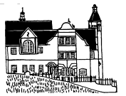
Learn to Live, Live to Learn

TEACHING AND LEARNING POLICY
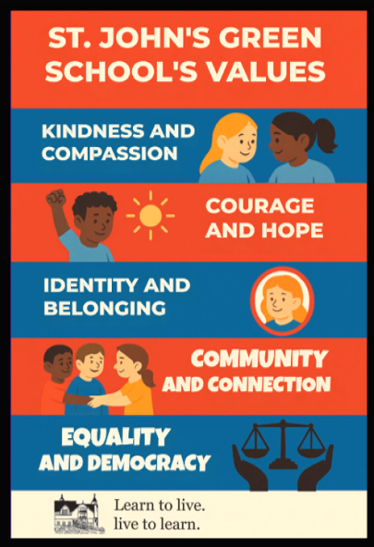

Teaching and Learning at St. John’s Green is about YOU, the children.

Our promise to you, the children, is that during your time at St. John’s Green, your learning journeys will be unique. You will take part in formal lessons, driven by the National Curriculum, as well as outside learning and cross-curricular activities, to broaden and enrich your learning experiences. As part of your learning, you will find out about different learning styles and you will have opportunities to use them all. We also have a specific curriculum, where you will learn about how to treat others and how to behave. You will go on visits and visitors will come into school, which will help to enrich your learning. You will grow into positive, responsible people, who can work and co-operate with others. You will develop knowledge, skills and attitudes to learning so that you will achieve your full potential and become lifelong learners.

St. John’s Green is a Visible Learning school. We are proud of this because we have researched the best ways to help children learn. Lessons in all subjects have a progression of skills and you will be taught the knowledge you need for each subject, which you will repeat and consolidate throughout your time here.

Your learning will involve being active in lessons, working collaboratively, making links in your learning, reflecting on feedback and being resilient. To encourage these learning behaviours, we have five ‘learning’ Superheroes: Resilience Rex, Collaborating Carlos, Making Links Mollie, Motivating Melinda and Reflecting Roxy.

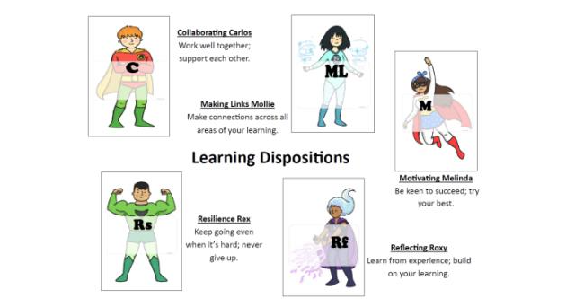

We will ensure that we use Growth Mindset to help you progress through your own learning journeys and their challenges; using strategies to help you out of The Learning Pit and onto new learning. We will encourage phrases such as: WE ARE ALL WRITERS, WE LOVE MATHS, READING IS THE KEY and I’M NOT THERE YETI to keep you motivated and engaged.

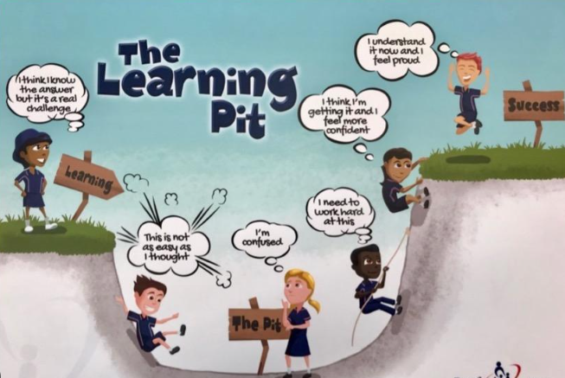

Our Curriculum is set out so that we embed the Learning Dispositions (Visible Learning), school values (Kindness, Compassion, Courage, Hope, Identity, Belonging, Community, Connection, Equality, Democracy) and the SCARF curriculum throughout the school year. Each term (Assessment Period), you will have assemblies which include the learning dispositions and our school values. These will be focused on across the weeks and celebrated in Well-done Assemblies as well.

We are Silver Awarded, Rights Respecting School and as part of this, we have UNICEF Ambassadors, who work alongside the democratically voted-in School Council. The Rights we focus on are: Article 17 (Information), Article 22 (Refugees), Article 14 (Freedom of thought, belief and religion), Article 28 (Right to education), Article 12 (Views of the child) and Article 2 (Non-discrimination). We hope that you will learn about these rights and understand the importance of them during your time with us.

Your teachers will:
- Have high expectations of behaviour and outcomes
- Teach with enthusiasm
- Take into account your prior learning and build on this in a systematic way
- Teach with focus
- Teach with pace
- Have clear learning outcomes
- Give opportunities to interact
- Motivate and encourage
- Ensure every child and groups of children’s needs are planned for
- Give feedback as soon as possible, through live marking and verbal conversations
- Give you opportunities to make links in your learning
- Give you opportunities to collaborate
- Give you opportunities to reflect on your learning to help you remember
- Encourage you to go into The Learning Pit

Your classrooms will:
- Have visual timetables
- Have working walls - this means you can use them to help you with your learning
- Have clear desks - to stop you from being distracted
- Have: a Road to Writing display, a Maths Flightpath display, a Growing Our Learning display (to help with STICKY KNOWLEDGE), vocabulary displays, Word of the Day words and a Learning Pit (to help you know where you are in your learning)
- Learning Journey books to show your learning journey for the whole year!

How will you know how you are doing?

We want you to make a year’s progress for a year’s teaching. Teachers will check your learning by: talking to you, marking your work and you will sometimes take part in assessed pieces of work, to help the teachers find out what you know and what you still need to know!

Your classwork will be marked in pink or green. Pink (Tickled Pink) means you have achieved the learning and green (Growing Green) means you need to check it or try again. Teachers will try to mark your work during the lessons because they (the teachers) know that letting children know how they are doing, as quickly as possible, is the best way to help them learn and make progress.

Through your learning journeys and time at St. John’ Green you will:

- Enjoy learning
- Feel successful
- Become creative and independent learners
- Have the flexibility to decide how best to learn in different situations
- Be able to talk about next steps in your learning
- Know what your strengths are and areas you need to develop
- Become lifelong learners
- Develop your critical thinking
- Understand the importance of truth fairness, equality, right and wrong
- Nurture positive relationships
- Understand Britain’s cultural heritage
- Explore your spiritual, moral, cultural, mental and physical development
- Make learning more meaningful by putting it into context
- Challenge yourselves and engage in deeper learning

Staff consulted:

Ratified by the Governing Body:

Review Date: Annual review date

