IS YOUR CHILD STARTING SCHOOL THIS SEPTEMBER?
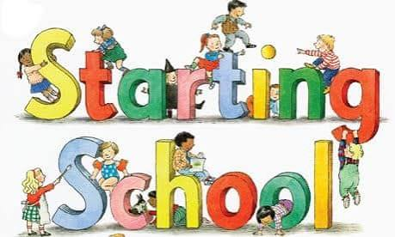

HERE’S A FEW THINGS TO HELP YOU OUT.

The school term for pupils starts on Wednesday 2nd September 2026.

On this day, the first session the children attend starts at 9.00a.m. until 11.00a.m. They enter school through the Learning Garden and will be met by their Teachers.
Parents are encouraged to come in briefly and to take photographs of their children starting school for the first time for memories.
Each child will be given a free book bag to bring home with a book inside.
Your child should also bring home a menu for Thursday and Friday when they are staying for lunch. Please complete and return to the school office.
All children in Reception classes are entitled to a free meal as part of the Universal Free School Meals programme.

On Thursday 3rd September, the session time will be from 9.00a.m. to 12.30 p.m. and they will stay for lunch.
On Friday 4th September, the session time will be from 9.00a.m. to 2.00 p.m. and they will stay for lunch.

Meal choices for Thursday and Friday are as below:
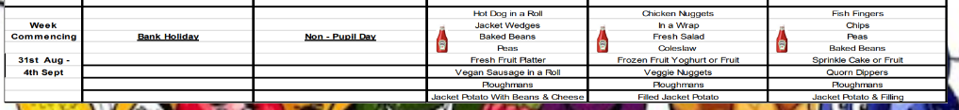

From Monday 7th September, all children will be expected to attend full time unless you have decided on a part-time basis until October half-term. Full time is dropping your child to school any time between 8.30 a.m. and 8.40 a.m., with registration at 8.40 a.m. and finish at 3.00 p.m.

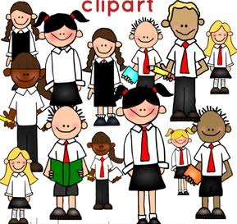
SCHOOL UNIFORM
Boys
- Grey or black trousers.
- Grey or black shorts (these must not be sports shorts).
- White collared shirt or white polo shirt. (White polo shirts with the school logo are available from the school uniform suppliers).
- Navy fleece, sweatshirt or jumper. (Fleeces and sweatshirts with the school logo are available from the school uniform suppliers).
- Black shoes or black trainers.
- Navy, brown or black closed-toe sandals.
Girls
- Grey or black trousers or skirt.
- Grey or black shorts. (These must not be sports/cycling shorts)
- White collared shirt or white polo shirt. (White polo shirts with the school logo are available from the school uniform suppliers).
- Navy fleece, sweatshirt, jumper or cardigan. (Fleeces and sweatshirts with the school logo are available from the school uniform suppliers).
- Blue checked summer dress.
- Grey pinafore.
- Sensible flat black shoes or black trainers.
- Navy, brown or black closed-toe sandals.


PE
At the beginning of the term, the children can come into school wearing their PE kits.
P.E. Kit for Foundation children:
  - Plain white polo shirt.
  - Navy blue or black shorts. (A small motif is permissible)
  - Plimsolls/pumps (No trainers)
At the term progresses, we will get the children to bring their PE kits in to school with them and keep them on their pegs. This forms part of the process in helping and teaching them to get changed for their PE lessons.
Children will be allocated their Teams at the end of the spring term.
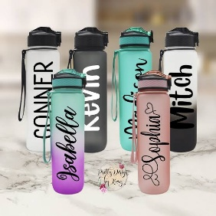
WATER BOTTLES AND SPARE CLOTHES
Children need to bring in a named water bottle every day.
It may be useful to send in a change of clothes that can be kept on their pegs. A coat will be required if the weather is wet, but also a sunhat could be beneficial if it is still hot and parents will need to have applied sun cream before school.
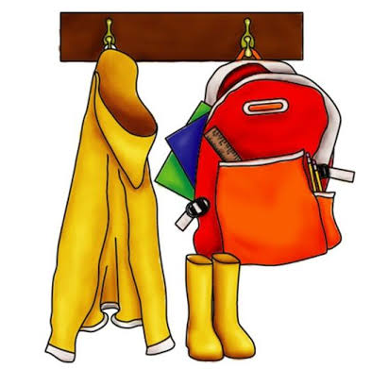
Children also need to have a pair of wellies – named – as they will be outside in all weathers.

Please ensure that all uniform and personal effects are NAMED clearly so that they can be returned if misplaced.

Finally, we welcome you all to the St John’s Green Primary School community.
If you have any questions at all, please do not hesitate to ask.

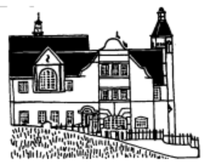
Learn to Live, Live to Learn

